Experiment -2 NAME: SRITHIKA.S ROLL NO:240701533
Design a UI where users recall visual elements (e.g., icons or text chunks). Evaluate the effect of chunking on user memory.
FRAME 1: INSTRUCTION PAGE:
Chunking Analysis of the Instruction Page
The interface follows the chunking principle, where information is broken into smaller, manageable blocks. Each block focuses on a single type of information, which improves readability and memory retention
Description
This frame displays the synonyms of the word “Happy”. Synonyms are words that have the same or similar meaning.
Elements Used
Title: Synonyms
Main word: Happy
List items: Joyful, Cheerful, Delighted, Elated
Color: Blue
Purpose
Helps users quickly learn words with similar meanings
Improves vocabulary by grouping related words
Design Explanation
Blue color creates a positive and calm feeling
Bullet points make the content easy to scan
Single-purpose frame reduces cognitive load
UI Principle Used
Chunking: Related words are grouped together
Visual hierarchy: Heading → main word → list
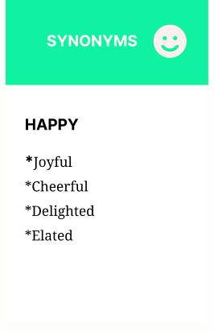

Frame 2: Antonyms
Description
This frame shows the antonyms (opposite meaning words) of “Happy”.
Elements Used
Title: Antonyms
Main word: Happy
List items: Sad, Unhappy, Miserable, Despondent
Color: Red
Purpose
Helps users understand the opposite meaning of the word
Improves contrast in learning and comprehension
Design Explanation
Red color represents negative or opposite emotions
Consistent layout with Frame 1 avoids confusion
Clear spacing improves readability
UI Principle Used
Color coding for quick recognition
Consistency in layout and structure

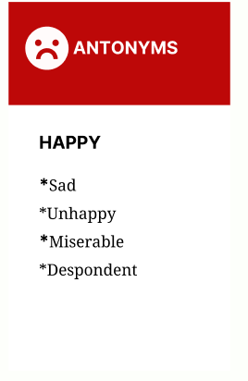

Frame 3: Examples
Description
This frame provides example sentences using the word “Happy”.
Elements Used
Title: Examples
Main word: Happy
Sentences:
She felt happy and content with her life.
He had a big, happy smile on his face.
The news made everyone feel happy.
Color: Green
Purpose
Helps users understand real-world usage
Reinforces learning through context
Design Explanation
Green color represents learning and clarity
Simple sentences improve understanding
Bullet points make examples easy to read
UI Principle Used
Contextual learning
Chunking: Examples separated from definitions

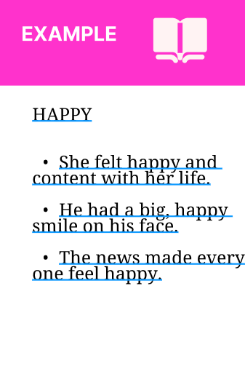

PROTOTYPE LINK:
https://www.figma.com/design/m0HQMKrgyKcmFK1nSLieen/Untitled?node-id=19-11
https://www.figma.com/design/m0HQMKrgyKcmFK1nSLieen/Untitled?node-id=21-23

